**Color example for approval for Alpha 2 prototypes (and possibly for production)**

**9/26/14**

The initial color requirement was for a color that matched the light silver grays of the metallic surface of products like the iPad. Metallic coatings look like metal because they contain metal, however the EKG module cannot have metal in the outer surfaces.

Previous color work had lead us to Pantone 420, which appears to be a close color match to the light silver gray color wanted. The color can be painted or molded into the case halves.

The last run of the 2 LED proto parts were painted to match Pantone 420.

Approval of Pantone color 420 for the Alpha 2 prototypes is requested. If 420 looks OK based on the colors shown below, plastic color chips will be ordered to help confirm the color.

A screen clip of Pantone 420 is below (ref. the letter suffix explanation at the bottom of this page)

**Pantone 420**

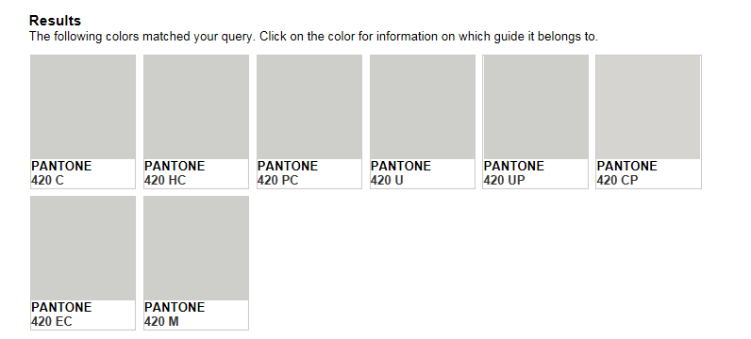

Note: The letter suffixes are explained here: <https://www.pantone.com/pages/Pantone/Pantone.aspx?pg=20051&ca=1>

However, the most common used letters are C for coated paper, U for uncoated paper, M for matte or dull paper.